### 

### Semester Two Examination, 2019

### Question/Answer booklet

# MATHEMATICS SPECIALIST

**UNIT 2**

## Section Two:

## Calculator-assumed

Your Name

Your Teacher’s Name

## Time allowed for this section

Reading time before commencing work: ten minutes

Working time: one hundred minutes

## Materials required/recommended for this section

***To be provided by the supervisor***

This Question/Answer booklet

Formula sheet (retained from Section One)

***To be provided by the candidate***

Standard items: pens (blue/black preferred), pencils (including coloured), sharpener, correction fluid/tape, eraser, ruler, highlighters

Special items: drawing instruments, templates, notes on two unfolded sheets of A4 paper, and up to three calculators approved for use in this examination

## Important note to candidates

No other items may be taken into the examination room. It is **your** responsibility to ensure that you do not have any unauthorised material. If you have any unauthorised material with you, hand it to the supervisor **before** reading any further.

| **Question** | **Marks** | **Max** | **Question** | **Marks** | **Max** |
| --- | --- | --- | --- | --- | --- |
| **10** |  | **4** | **17** |  | **8** |
| **11** |  | **7** | **18** |  | **5** |
| **12** |  | **6** | **19** |  | **10** |
| **13** |  | **10** | **20** |  | **10** |
| **14** |  | **7** | **21** |  | **12** |
| **15** |  | **5** | **22** |  | **6** |
| **16** |  | **4** |  |  |  |

**Structure of this paper**

| Section | Number of questions available | Number of questions to be answered | Working time (minutes) | Marks available | Percentage of examination |
| --- | --- | --- | --- | --- | --- |
| Section One:  Calculator-free | 9 | 9 | 50 | 52 | 36 |
| Section Two:  Calculator-assumed | 13 | 13 | 100 | 94 | 64 |
|  |  |  |  | **Total** | 100 |

**Instructions to candidates**

1. The rules for the conduct of the Western Australian Certificate of Education ATAR course examinations are detailed in the *Year 12 Information Handbook 2019*. Sitting this examination implies that you agree to abide by these rules.
2. Write your answers in this Question/Answer booklet.
3. You must be careful to confine your answers to the specific questions asked and to follow any instructions that are specific to a particular question.
4. Additional pages for the use of planning your answer to a question or continuing your answer to a question have been provided at the end of this Question/Answer booklet. If you use the space to continue an answer, indicate in the original answer space where the answer is continued, i.e. give the page number.
5. **Show all your working clearly.**Your working should be in sufficient detail to allow your answers to be checked readily and for marks to be awarded for reasoning. Incorrect answers given without supporting reasoning cannot be allocated any marks. For any question or part question worth more than two marks, valid working or justification is required to receive full marks. If you repeat any question, ensure that you cancel the answer you do not wish to have marked.
6. It is recommended that you **do not use pencil**, except in diagrams.
7. The Formula sheet is **not** to be handed in with your Question/Answer booklet.

**See Next Page**

**Section Two: Calculator-assumed (94 Marks)**

This section has **thirteen (13)** questions. Answer **all** questions. Write your answers in the spaces provided.

Spare pages are included at the end of this booklet. They can be used for planning your responses and/or as additional space if required to continue an answer.

● Planning: If you use the spare pages for planning, indicate this clearly at the top of the page.

● Continuing an answer: If you need to use the space to continue an answer, indicate in the original answer space where the answer is continued, i.e. give the page number. Fill in the number of the question that you are continuing to answer at the top of the page.

Working time: 100 minutes.

**Question 10 (4 marks)**

Given the following graph for $y=asinsin \left(b\left(x-c\right)\right)+d$, state the values of $a,b$, $c$ and $d$  
(all unknowns are **positive** numbers).

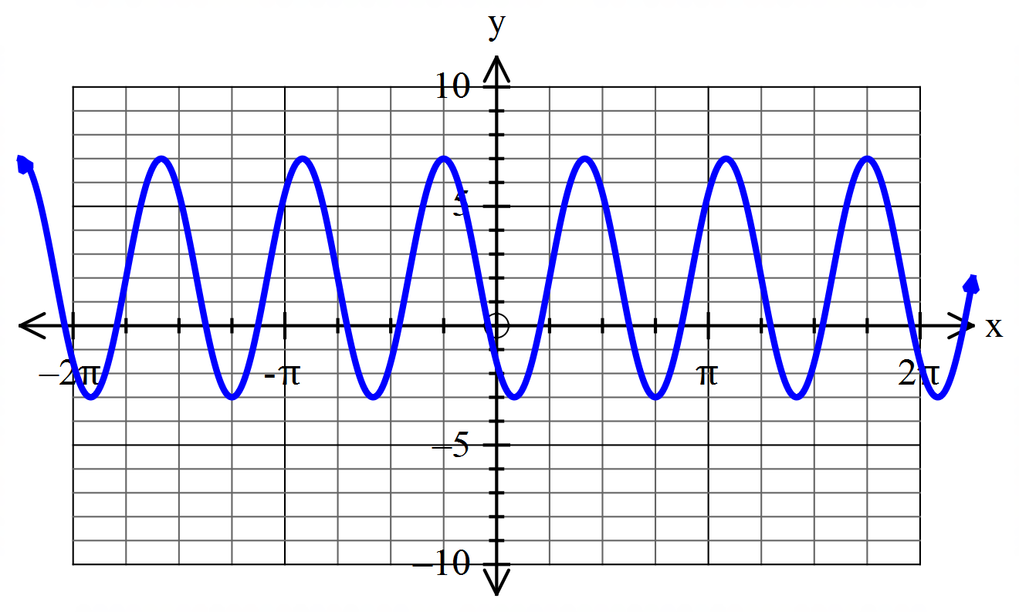

**Question 11 (7 marks)**

The water depth, $h$ metres, measured from the bottom of a lake $t$ hours **after 6 am** is modelled by the function

$h=8-3sinsin \left(\frac{π}{3}\left(t-\frac{1}{2}\right)\right)$

1. Determine the water depth at 12 noon.(2 marks)
2. Determine the first time (after 6 am) when the water depth is at a maximum.(3 marks)
3. Determine the length of time before noon (in hours) when the water depth is less than

8 m.(2 marks)

**Question 12 (6 marks)**

Determine the number of four letter “words” (i.e. distinct arrangements of 4 letters) that can be made using the letters of the word FOURTH if:

1. there are no restrictions. (1 mark)
2. the T and H must be together, in that order, at the start of the word. (2 marks)
3. the letters T and H must be together, in any order, anywhere in the word, and there must be at least one vowel in the word. (3 marks)

**Question 13 (10 marks)**

Airports $A$ and $B$ are such that the vector $\vec{AB}=(-350i+650j)$ km. A helicopter is to be flown directly from $A$ to $B$, and in still air the helicopter can maintain a steady speed of 180km/h. There is a wind blowing with a velocity of $\left(-12i-3j\right)$ km/h.

1. Draw a diagram to represent this information, using $ai+bj$ to represent the velocity vector the helicopter should set to follow the shortest path from $A$ to $B$. (1 mark)
2. Determine the velocity vector $ai+bj$ defined in part (a) (assuming the wind maintains the same strength and direction for the duration of the journey). Give answers to 2 decimal places. (4 marks)
3. Calculate the resultant speed of the helicopter, giving your answer to 2 decimal places.

(2 marks)

1. Determine to the nearest minute the time it will take for the helicopter to travel from $A$ to $B$. (2 marks)
2. Assuming the wind maintains the same strength and direction, find, in the form $ci+dj$, the velocity vector the pilot should take for the return journey from $B$ to $A$, giving answers to 2 decimal places. (1 mark)

**Question 14 (7 marks)**

Of the ten players in the squad for a basketball team, three are primarily guards, two are primarily centres and five are primarily forwards. Determine how many different teams of five could be chosen if:

1. there are no restrictions. (1 mark)
2. there must be one centre, two forwards and two guards. (2 marks)
3. there must be at least one guard. (2 marks)
4. there must be at least one guard and no centres. (2 marks)

**Question 15 (5 marks)**

Prove the following identity:

csc $(x) +cotcot (x) =\frac{2tantan (x) coscos (x) +sinsin (2x) }{1-coscos \left(2x\right) }$

**Question 16 (4 marks)**

How many positive integers strictly less than 1000 are divisible by 5, 7, or 9?

**Question 17 (8 marks)**

1. Identify the matrix $T$ that will rotate points $90°$ anticlockwise about the origin. (1 mark)
2. Find the image of $(-4,7)$ following a transformation by $T$. (2 marks)
3. Identify the matrix $Q$ that represents the single transformation with the same effect as first reflecting in the line $y=\sqrt{3}x$ and then dilating vertically by a factor of 3. (5 marks)

**Question 18 (5 marks)**

1. Simplify the following expression into its simplest factorial form. (2 marks)
$\frac{100!-99!}{99}$

2. Prove that

$\frac{\left(n+3\right)!+(n+2)!+(n+1)!}{\left(n+1\right)!} ={\left(n+3\right)}^{2}$

(3 marks)

**Question 19 (10 marks)**

Two perpendicular lines are each tangent to a circle of radius 1 at points $A$ and $B$. The centre of the circle is $C$. 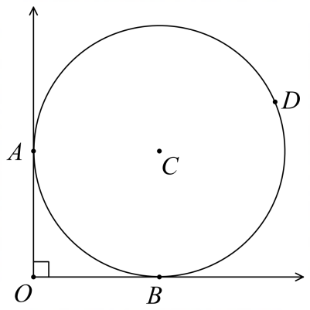

a) Prove that $∠ACB=90°$. (3 marks)

b) Prove that $∠OBA=45°$. (2 marks)

c) Point $D$ lies on the circle such that $∠OBD=105°$. Find the distance $AD$ as an **exact value**.

(5 marks)

**Question 20 (10 marks)**

1. If $u=8i-4j$ and $v=6i+4j$ determine
2. $u∙v$ (1 mark)
3. the angle between the vectors $u$ and $v$, to the nearest tenth of a degree.

(2 marks)

1. the scalar projection of $v$ on $u$. (2 marks)

1. The vector $21i+7mj$ has a magnitude of 35 and is perpendicular to the vector $5i-4nj$. Determine the values of the constants $m$ and $n$, where $m>n$. (5 marks)

**Question 21 (12 marks)**

1. Solve the matrix equation $BA+A=B-I$, where $I=\left[1 0 0 1 \right]$ and $B=\left[1 2 -3 1 \right]$, to determine the matrix $A$. (4 marks)
2. Let $P=\left[k-1 1 6 4 \right]$ and $Q=\left[4 -1 -6 k-1 \right]$. Determine the value of $k$ if $P×Q=P+Q$.

(3 marks)

1. Preimage $ABCDEFG$ is transformed by the single matrix $T=\left[a b c d \right]$ to Image $A’B’C’D’E’F’G’$.

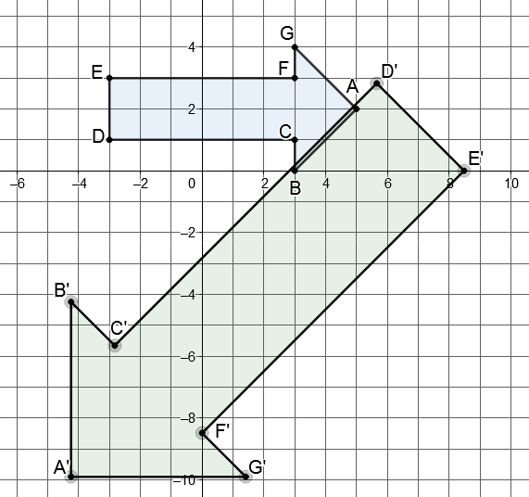

1. Given $A^{'}\left(-3\sqrt{2},-7\sqrt{2}\right)$ and $G^{'}\left(\sqrt{2},-7\sqrt{2}\right)$, determine the matrix $T$. (2 marks)
2. Find the area of the Image $A’B’C’D’E’F’G’$. (3 marks)

**Question 22 (6 marks)**

Three forces act on an object at point $P$ such that the system is in equilibrium. These forces are represented with vectors as shown in the diagram, where $θ$ is acute. Determine the values of $θ$ and $k$, giving answers to 2 decimal places.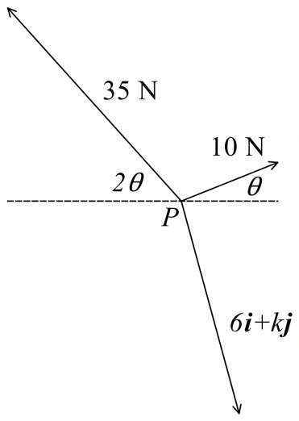

**END OF QUESTIONS**

**Additional working space**

Question number:

**Additional working space**

Question number:

**Additional working space**

Question number: